Name of the Student: G. Manasa | Academic Year:
Student Registration Number: 241U1R3007 | Year & Term:
Study Level: B-Tech | Class & Section: CSE-DS
Name of the Course: Digital Electronics | Name of the Instructor:
Name of the Assessment: lab report 10 | Date of Submission: 17-08-2025

Simulation of Asynchronous and Synchronous Counters
Simulation of Asynchronous Counters using JK Flip-Flops

1.Objective
- Design and simulate a 4-bit asynchronous (ripple) binary up counter using JK flip-flops in Logisim.
- Design and simulate a 4-bit asynchronous down counter using JK flip-flops in Logisim.
- Design and simulate a 4-bit asynchronous up-down counter using JK flip-flops in Logisim.
- Observe and record the counting sequence and verify expected outputs.

2.Apparatus Required:
PC with Logisim installed.

3.Theory
Asynchronous (ripple) counters operate by clocking only the first flip-flop with the external clock, while subsequent flip-flops are clocked by outputs of the preceding flip-flops. JK flip-flops can toggle when both inputs J=1 and K=1, which makes them highly suitable for counter design.
JK Flip-Flop Characteristics
- Inputs: J, K, CLK, Q, Q̄
- Function: When J=K=1, Q toggles on every active clock edge.
- For counters, tie J=K=1 to force toggling on each clock.

4.Procedure
- Create new project async_jk_counters.circ.
- Build 4-bit up counter, run and record outputs.
- Build 4-bit down counter, run and record outputs.
- Build 4-bit up-down counter with mode control.
- Record observations.

5.Design and Implementation
A. 4-bit Asynchronous Up Counter
Each JK flip-flop toggles by setting J=K=1. First flip-flop is driven by external clock, others by the Q output of previous stage.
Steps:
- Place 4 JK flip-flops. Label outputs Q0 (LSB), Q1, Q2, Q3 (MSB).
- Tie J=K=1 for all flip-flops.
- Connect external clock → CLK of Q0.
- Q0 → CLK of Q1, Q1 → CLK of Q2, Q2 → CLK of Q3.
- Connect outputs Q0–Q3 to LEDs.
Counts 0 → 15 → repeat
Clock Pulse | Q3 | Q2 | Q1 | Q0 | Decimal
0 | 0 | 0 | 0 | 0 | 0
1 | 0 | 0 | 0 | 1 | 1
2 | 0 | 0 | 1 | 0 | 2
3 | 0 | 0 | 1 | 1 | 3
4 | 0 | 1 | 0 | 0 | 4
5 | 0 | 1 | 0 | 1 | 5
6 | 0 | 1 | 1 | 0 | 6
7 | 0 | 1 | 1 | 1 | 7
8 | 1 | 0 | 0 | 0 | 8
9 | 1 | 0 | 0 | 1 | 9
10 | 1 | 0 | 1 | 0 | 10
11 | 1 | 0 | 1 | 1 | 11
12 | 1 | 1 | 0 | 0 | 12
13 | 1 | 1 | 0 | 1 | 13
14 | 1 | 1 | 1 | 0 | 14
15 | 1 | 1 | 1 | 1 | 15
16 → | 0 | 0 | 0 | 0 | 0
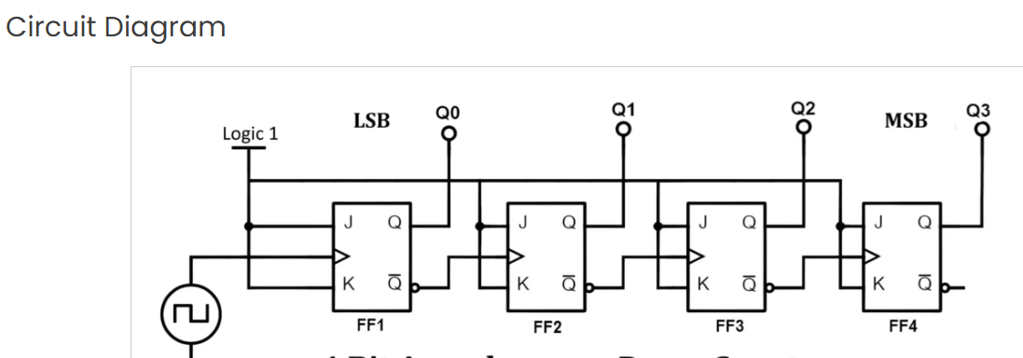

Simulation:

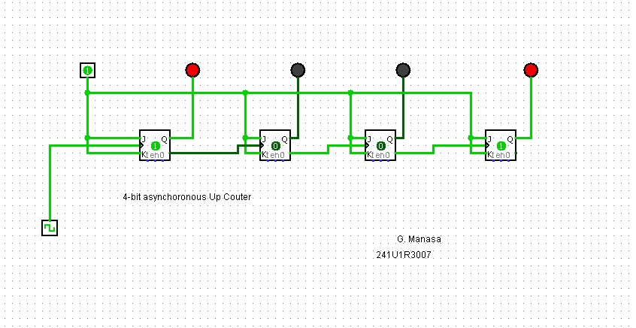
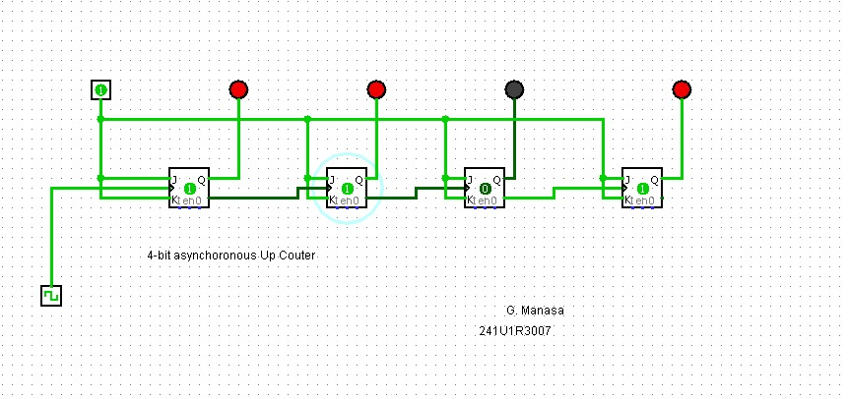
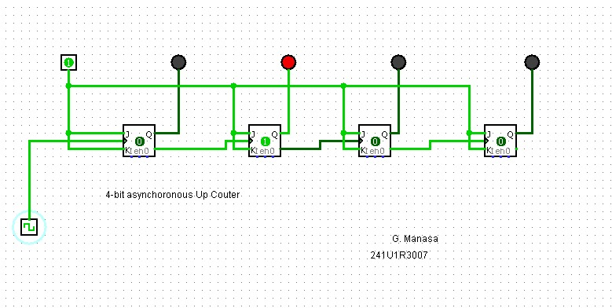
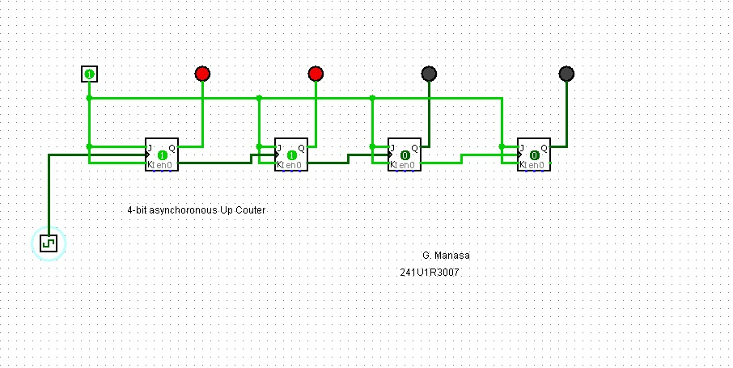
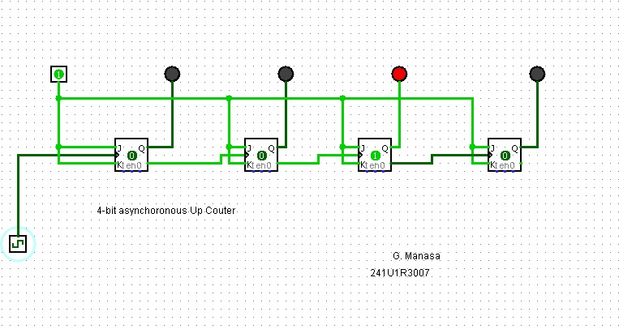

B. 4-bit Asynchronous Down Counter
Similar to up counter, but use Q̄ outputs to drive the next stage, producing reverse sequence.
Steps:
- Place 4 JK flip-flops with J=K=1.
- Connect external clock → CLK of Q0.
- Use Q̄0 → CLK of Q1, Q̄1 → CLK of Q2, Q̄2 → CLK of Q3.
- LEDs on Q outputs.
Counts 15 → 0 → repeat.
 |  |  |  |  |  | Clock Pulse | Q3 | Q2 | Q1 | Q0 | Decimal
 |  |  |  |  |  | 0 | 1 | 1 | 1 | 1 | 15
 |  |  |  |  |  | 1 | 1 | 1 | 1 | 0 | 14
 |  |  |  |  |  | 2 | 1 | 1 | 0 | 1 | 13
 |  |  |  |  |  | 3 | 1 | 1 | 0 | 0 | 12
 |  |  |  |  |  | 4 | 1 | 0 | 1 | 1 | 11
 |  |  |  |  |  | 5 | 1 | 0 | 1 | 0 | 10
 |  |  |  |  |  | 6 | 1 | 0 | 0 | 1 | 9
 |  |  |  |  |  | 7 | 1 | 0 | 0 | 0 | 8
 |  |  |  |  |  | 8 | 0 | 1 | 1 | 1 | 7
 |  |  |  |  |  | 9 | 0 | 1 | 1 | 0 | 6
 |  |  |  |  |  | 10 | 0 | 1 | 0 | 1 | 5
 |  |  |  |  |  | 11 | 0 | 1 | 0 | 0 | 4
 |  |  |  |  |  | 12 | 0 | 0 | 1 | 1 | 3
 |  |  |  |  |  | 13 | 0 | 0 | 1 | 0 | 2
 |  |  |  |  |  | 14 | 0 | 0 | 0 | 1 | 1
 |  |  |  |  |  | 15 | 0 | 0 | 0 | 0 | 0
 |  |  |  |  |  | 16 → | 1 | 1 | 1 | 1 | 15

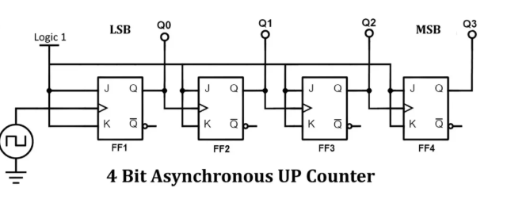

Simulation:
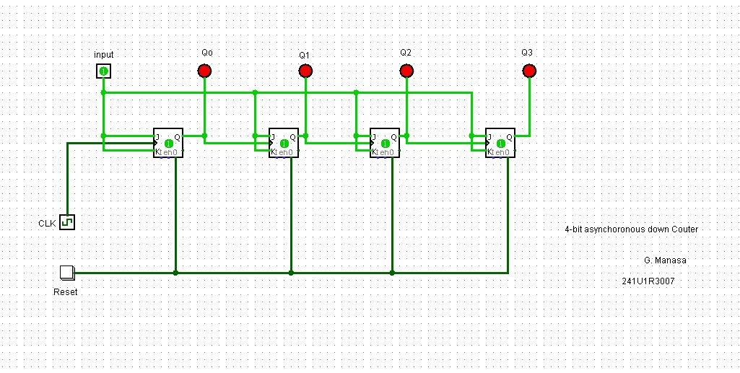
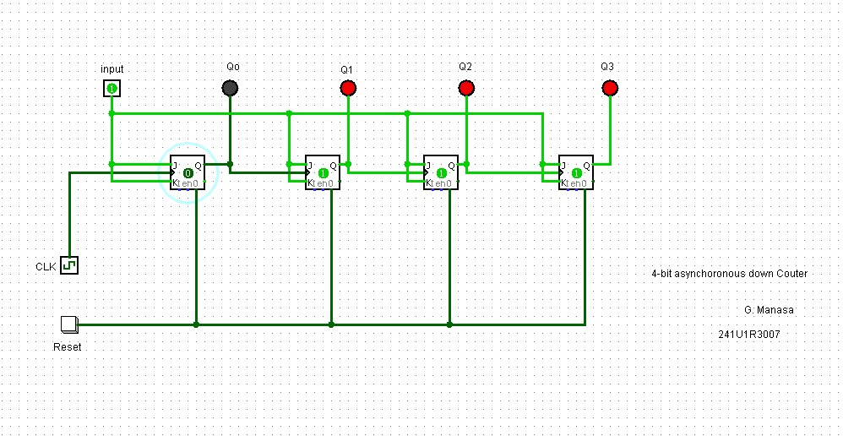
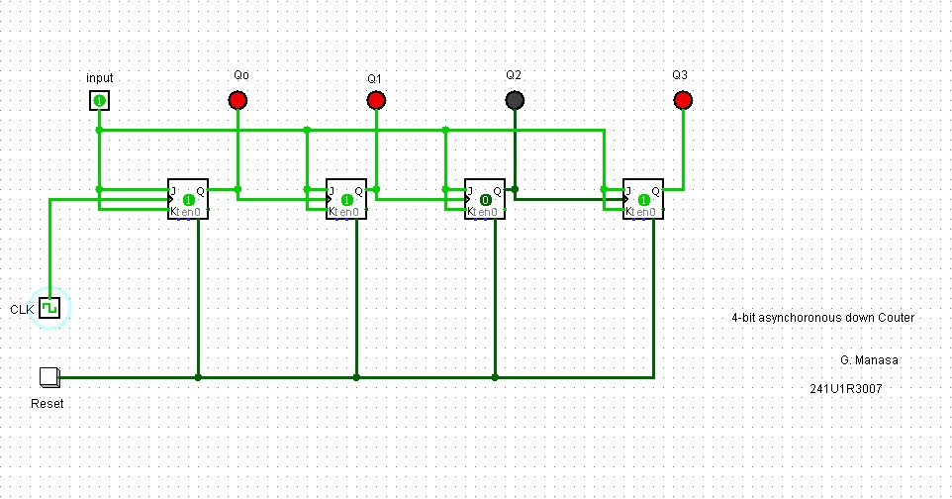
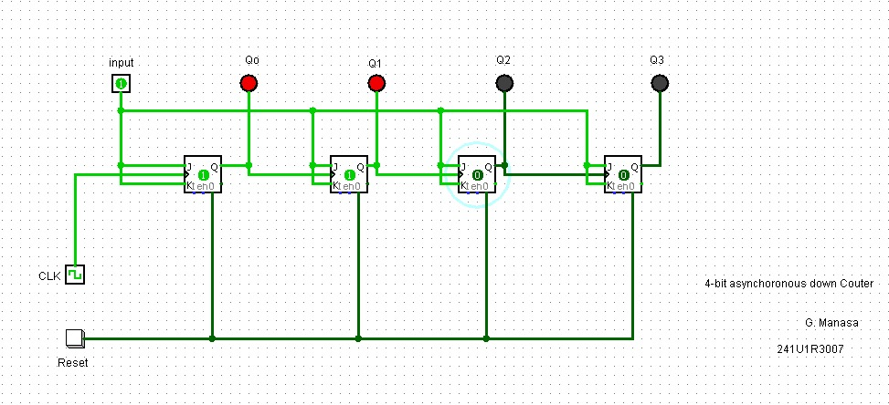
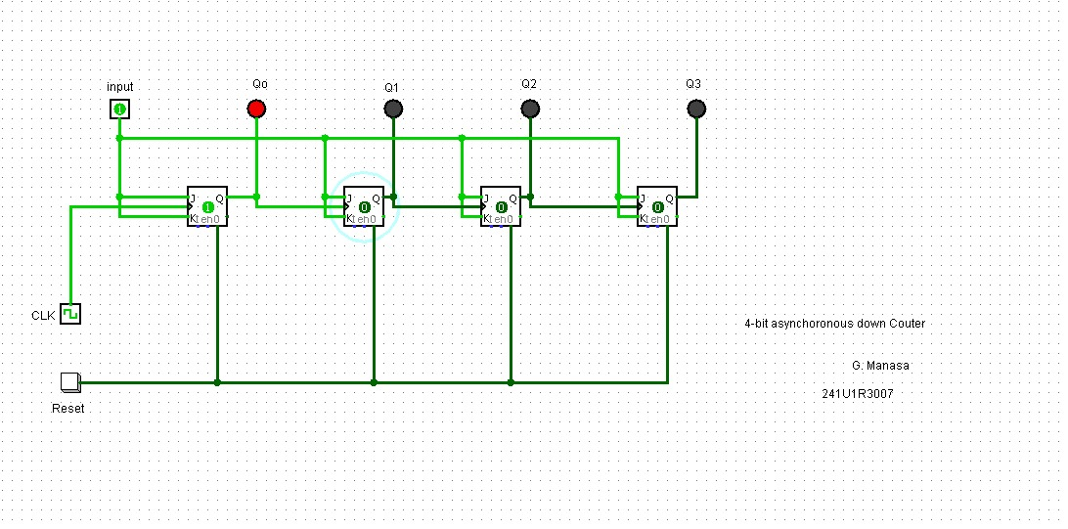
C. 4-bit Asynchronous Up-Down Counter
Allow selection of up or down mode with a control input (UP/DOWN). Use multiplexing logic to decide whether to feed Q or Q̄ of each stage as the clock input to the next.
Steps:
- Place 4 JK flip-flops with J=K=1.
- Add a control input M (Mode: 0=Up, 1=Down).
- For each stage, use a multiplexer (MUX) to select between Q and Q̄ as the clock input to the next flip-flop:
  - If M=0 → Q feeds next clock (Up).
  - If M=1 → Q̄ feeds next clock (Down).
- Connect LEDs to Q outputs.

Case 1: UP Counting (M = 1)
Clock Pulse | Q3 | Q2 | Q1 | Q0 | Decimal
0 | 0 | 0 | 0 | 0 | 0
1 | 0 | 0 | 0 | 1 | 1
2 | 0 | 0 | 1 | 0 | 2
3 | 0 | 0 | 1 | 1 | 3
4 | 0 | 1 | 0 | 0 | 4
5 | 0 | 1 | 0 | 1 | 5
6 | 0 | 1 | 1 | 0 | 6
7 | 0 | 1 | 1 | 1 | 7
8 | 1 | 0 | 0 | 0 | 8
9 | 1 | 0 | 0 | 1 | 9
10 | 1 | 0 | 1 | 0 | 10
11 | 1 | 0 | 1 | 1 | 11
12 | 1 | 1 | 0 | 0 | 12
13 | 1 | 1 | 0 | 1 | 13
14 | 1 | 1 | 1 | 0 | 14
15 | 1 | 1 | 1 | 1 | 15
16 → | 0 | 0 | 0 | 0 | 0 (Repeat)

Case 2: DOWN Counting (M = 0)
Clock Pulse | Q3 | Q2 | Q1 | Q0 | Decimal
0 | 1 | 1 | 1 | 1 | 15
1 | 1 | 1 | 1 | 0 | 14
2 | 1 | 1 | 0 | 1 | 13
3 | 1 | 1 | 0 | 0 | 12
4 | 1 | 0 | 1 | 1 | 11
5 | 1 | 0 | 1 | 0 | 10
6 | 1 | 0 | 0 | 1 | 9
7 | 1 | 0 | 0 | 0 | 8
8 | 0 | 1 | 1 | 1 | 7
9 | 0 | 1 | 1 | 0 | 6
10 | 0 | 1 | 0 | 1 | 5
11 | 0 | 1 | 0 | 0 | 4
12 | 0 | 0 | 1 | 1 | 3
13 | 0 | 0 | 1 | 0 | 2
14 | 0 | 0 | 0 | 1 | 1
15 | 0 | 0 | 0 | 0 | 0
16 → | 1 | 1 | 1 | 1 | 15 (Repeat)

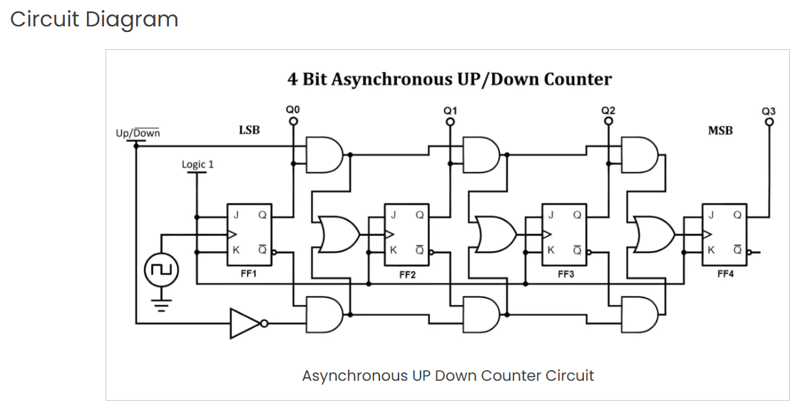
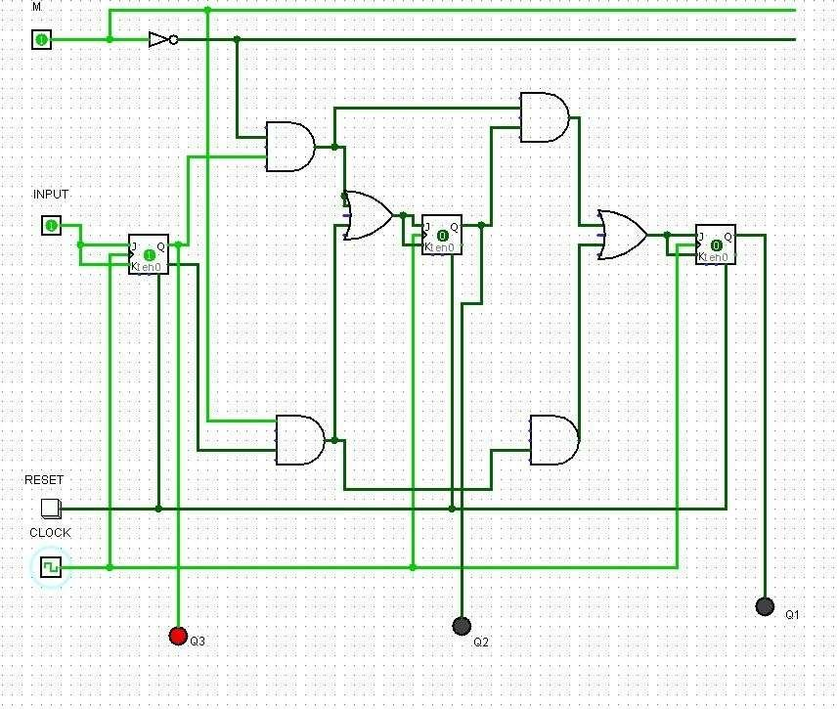

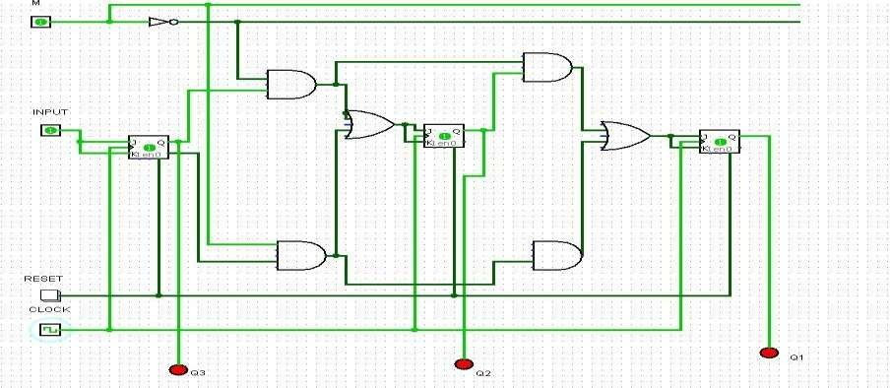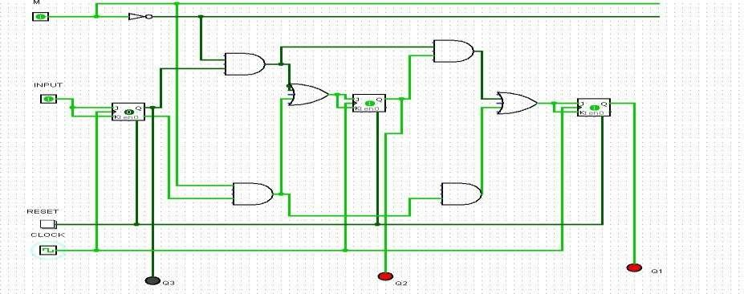

6.Result
- Successfully designed and simulated 4-bit asynchronous up, down, up-down counters using JK flip-flops in Logisim.
- Verified correct counting sequences.
Simulation of Synchronous Counters using JK Flip-Flops
1.Objective
- Design and simulate a 4-bit synchronous up counter using JK flip-flops in Logisim.
- Design and simulate a 4-bit synchronous down counter using JK flip-flops in Logisim.
- Design and simulate a 4-bit synchronous up/down counter using JK flip-flops in Logisim.
- Verify counting sequences and understand synchronous operation advantages over asynchronous.
2.Apparatus Required:
PC with Logisim installed.
3.Theory
Counters are sequential circuits that progress through a sequence of states depending on clock pulses. Unlike asynchronous (ripple) counters, synchronous counters use a common clock input for all flip-flops, ensuring simultaneous state changes and avoiding ripple delays.
JK Flip-Flop Operation (when J=K=1):
- Toggles its state (Q → ¬Q) on each active clock edge.
- Controlled toggling can be achieved by enabling inputs with logic expressions depending on lower-order outputs.
4-bit Synchronous Counter Design:
- Up Counter: Each higher-order flip-flop toggles when all lower-order outputs are HIGH.
- Down Counter: Each higher-order flip-flop toggles when all lower-order outputs are LOW.
- Up/Down Counter: Mode control signal (M) selects between Up and Down logic conditions.
4.Procedure
- Open Logisim and create a new project sync_jk_counters.circ.
- Implement the 4-bit synchronous up counter using JK flip-flops and logic gates.
- Verify the counting sequence by applying a clock.
- Repeat for the down counter using modified logic.
- Implement the up/down counter using mode input M.
- Test circuits and note outputs.

5.Design and Implementation
A. 4-bit Synchronous Up Counter
Logic design:
- J0 = K0 = 1 (LSB toggles every clock pulse).
- J1 = K1 = Q0.
- J2 = K2 = Q0·Q1.
- J3 = K3 = Q0·Q1·Q2.

Clock Pulse | Q3 | Q2 | Q1 | Q0 | Decimal
0 | 0 | 0 | 0 | 0 | 0
1 | 0 | 0 | 0 | 1 | 1
2 | 0 | 0 | 1 | 0 | 2
3 | 0 | 0 | 1 | 1 | 3
4 | 0 | 1 | 0 | 0 | 4
5 | 0 | 1 | 0 | 1 | 5
6 | 0 | 1 | 1 | 0 | 6
7 | 0 | 1 | 1 | 1 | 7
8 | 1 | 0 | 0 | 0 | 8
9 | 1 | 0 | 0 | 1 | 9
10 | 1 | 0 | 1 | 0 | 10
11 | 1 | 0 | 1 | 1 | 11
12 | 1 | 1 | 0 | 0 | 12
13 | 1 | 1 | 0 | 1 | 13
14 | 1 | 1 | 1 | 0 | 14
15 | 1 | 1 | 1 | 1 | 15
16 → resets | 0 | 0 | 0 | 0 | 0

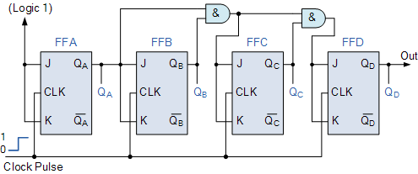
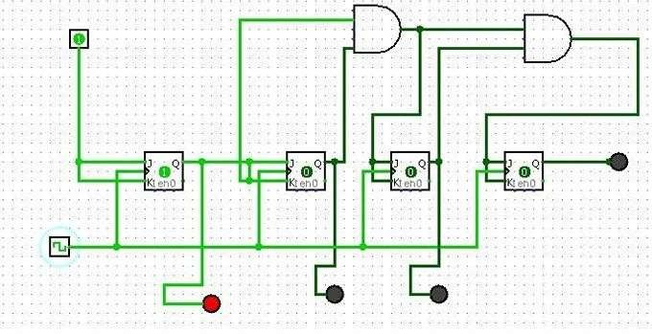
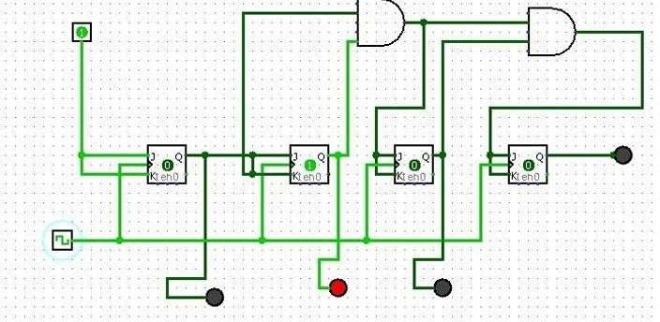
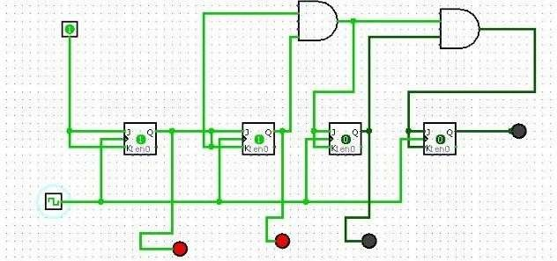
B. 4-bit Synchronous Down Counter
Logic design:
- J0 = K0 = 1.
- J1 = K1 = Q̄0.
- J2 = K2 = Q̄0·Q̄1.
- J3 = K3 = Q̄0·Q̄1·Q̄2.

Clock Pulse | Q3 | Q2 | Q1 | Q0 | Decimal
0 | 1 | 1 | 1 | 1 | 15
1 | 1 | 1 | 1 | 0 | 14
2 | 1 | 1 | 0 | 1 | 13
3 | 1 | 1 | 0 | 0 | 12
4 | 1 | 0 | 1 | 1 | 11
5 | 1 | 0 | 1 | 0 | 10
6 | 1 | 0 | 0 | 1 | 9
7 | 1 | 0 | 0 | 0 | 8
8 | 0 | 1 | 1 | 1 | 7
9 | 0 | 1 | 1 | 0 | 6
10 | 0 | 1 | 0 | 1 | 5
11 | 0 | 1 | 0 | 0 | 4
12 | 0 | 0 | 1 | 1 | 3
13 | 0 | 0 | 1 | 0 | 2
14 | 0 | 0 | 0 | 1 | 1
15 | 0 | 0 | 0 | 0 | 0
16 → resets | 1 | 1 | 1 | 1 | 15

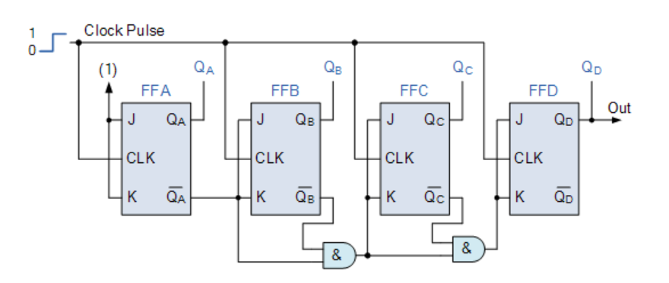
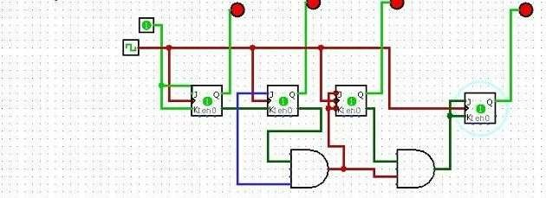
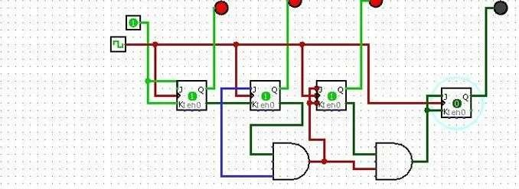
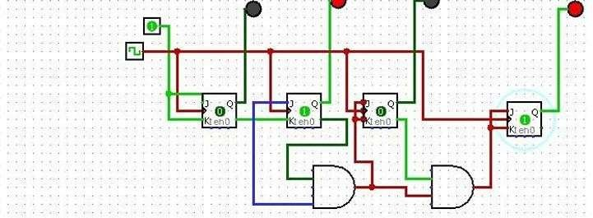

C. 4-bit Synchronous Up/Down Counter
Logic design (using Mode input M):
- J0 = K0 = 1.
- J1 = K1 = (M·Q0) + (M̄·Q̄0).
- J2 = K2 = (M·Q0·Q1) + (M̄·Q̄0·Q̄1).
- J3 = K3 = (M·Q0·Q1·Q2) + (M̄·Q̄0·Q̄1·Q̄2).
Clock Pulse | M | Q3 | Q2 | Q1 | Q0 | Decimal
0 | 1 | 0 | 0 | 0 | 0 | 0
1 | 1 | 0 | 0 | 0 | 1 | 1
2 | 1 | 0 | 0 | 1 | 0 | 2
3 | 1 | 0 | 0 | 1 | 1 | 3
4 | 1 | 0 | 1 | 0 | 0 | 4
5 | 1 | 0 | 1 | 0 | 1 | 5
6 | 1 | 0 | 1 | 1 | 0 | 6
7 | 1 | 0 | 1 | 1 | 1 | 7
8 | 1 | 1 | 0 | 0 | 0 | 8
9 | 1 | 1 | 0 | 0 | 1 | 9
10 | 1 | 1 | 0 | 1 | 0 | 10
11 | 1 | 1 | 0 | 1 | 1 | 11
12 | 1 | 1 | 1 | 0 | 0 | 12
13 | 1 | 1 | 1 | 0 | 1 | 13
14 | 1 | 1 | 1 | 1 | 0 | 14
15 | 1 | 1 | 1 | 1 | 1 | 15
16 → resets | 1 | 0 | 0 | 0 | 0 | 0

Clock Pulse | M | Q3 | Q2 | Q1 | Q0 | Decimal
0 | 0 | 1 | 1 | 1 | 1 | 15
1 | 0 | 1 | 1 | 1 | 0 | 14
2 | 0 | 1 | 1 | 0 | 1 | 13
3 | 0 | 1 | 1 | 0 | 0 | 12
4 | 0 | 1 | 0 | 1 | 1 | 11
5 | 0 | 1 | 0 | 1 | 0 | 10
6 | 0 | 1 | 0 | 0 | 1 | 9
7 | 0 | 1 | 0 | 0 | 0 | 8
8 | 0 | 0 | 1 | 1 | 1 | 7
9 | 0 | 0 | 1 | 1 | 0 | 6
10 | 0 | 0 | 1 | 0 | 1 | 5
11 | 0 | 0 | 1 | 0 | 0 | 4
12 | 0 | 0 | 0 | 1 | 1 | 3
13 | 0 | 0 | 0 | 1 | 0 | 2
14 | 0 | 0 | 0 | 0 | 1 | 1
15 | 0 | 0 | 0 | 0 | 0 | 0
16 → resets | 0 | 1 | 1 | 1 | 1 | 15

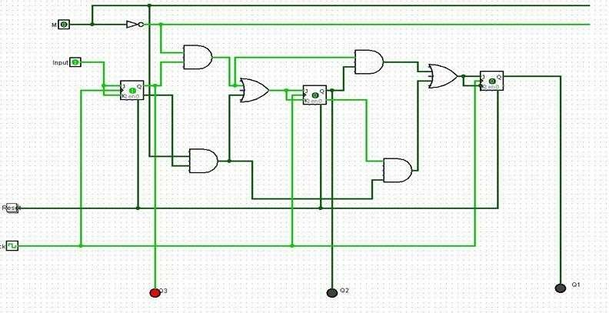
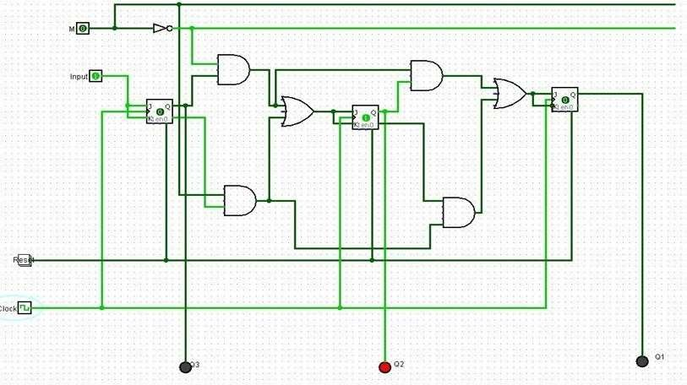
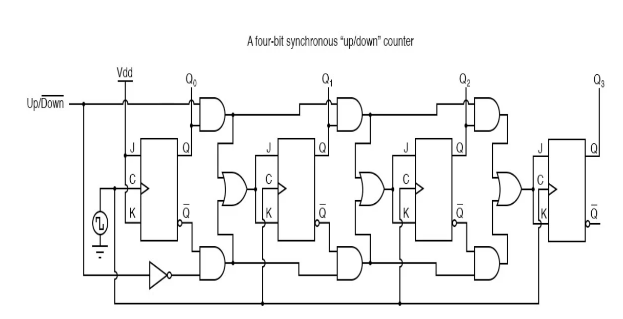

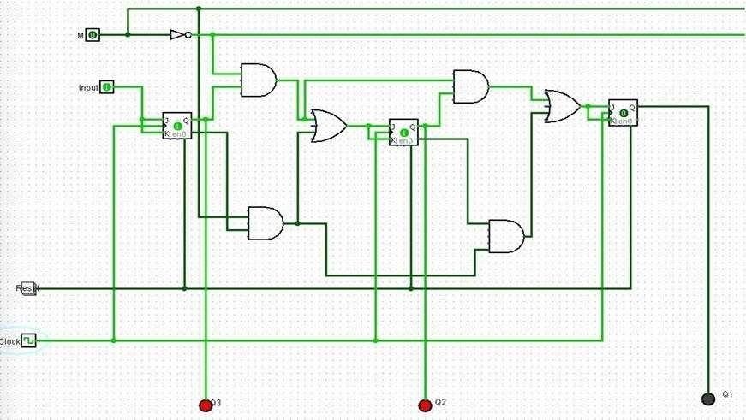

6.Conclusion
- Successfully designed and simulated 4-bit synchronous up, down, and up/down counters using JK flip-flops in Logisim.
- Verified correct counting sequences.
- Observed that synchronous counters are faster and more reliable compared to asynchronous counters.

